**TABLE OF CONTENTS**

|  |  |
| --- | --- |
| **TOPICS** | ***Page no*.** |
| 1. **Title Page** | 1 |
| 1. **Table of Content** | 2 |
| 1. **Theory** | 3-5 |
| 1. **Apparatus** | 6 |
| 1. **Analysis and Calculation** | 6 |
| 1. **Result** | 7 |
| 1. **Discussion** | 7-8 |
| 1. **References** | 8 |

1. **Theory**

The wave which’s motion in which all points on a wave oscillate along paths at right angles to the direction of the wave's advance is called Transverse wave. A longitudinal wave is a wave in which the disturbance moves in the same direction as the propagation of the wave. Melde’s experiment set up a light string is tied to one of the prongs of a tuning fork which is mounted on a sounding board. The other end of the string is passed over a horizontal pulley and a light pan is suspended from the free end.

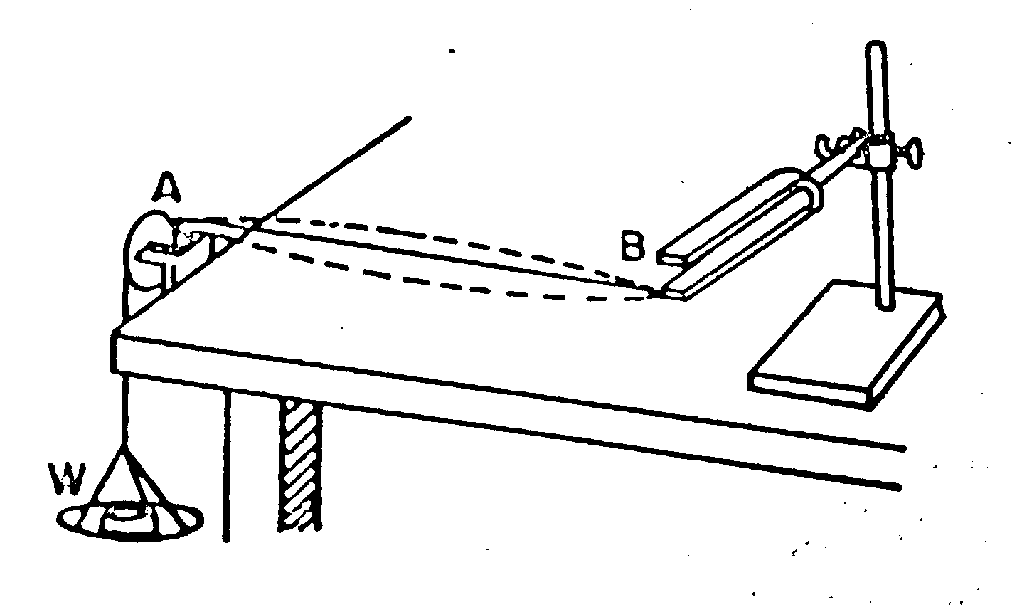

**Figure 1:** Arrangement of Melde’s experiment

Let one end of B of the string be attached to one prong of the fork F. The other end A passes over a small pulley and is attached to a scale pan. the string will be set into vibration by setting the turning fork into vibration. as a result, waves will proceed along the length of the string and will be reflected back on reaching the fixed end of the string. T superposition of the direct and reflected waves with form stationary waves, in which the extreme fixed ends of the string will always be nodes and in between them there may be one or more empty nodes depending on the attention of which the string is subjected or the length of the string.

If the tension is suitably adjusted the frequency $f$ of the fork may be made to equal to the frequency $f^{'}$ of the fundamental or anyone of the higher tones of the string. when this happens, a resonance is said to have occurred between the pork and the particular mode of vibration of the string.

If the node of vibration be assumed to be fundamental then the wavelength $λ=2l$, where $l$ is the length of the string. The frequency of the fork will then be given by the relation,

$$f=f^{'}=\frac{1}{λ}\sqrt{\frac{τ}{2l}}=\frac{1}{2l}\sqrt{\frac{τ}{μ}}$$

Where $μ$ is the mass per unit length of the vibrating string in grams and $τ$ is the tension applied to the string and is expressed in absolute units, dynes or pounds.

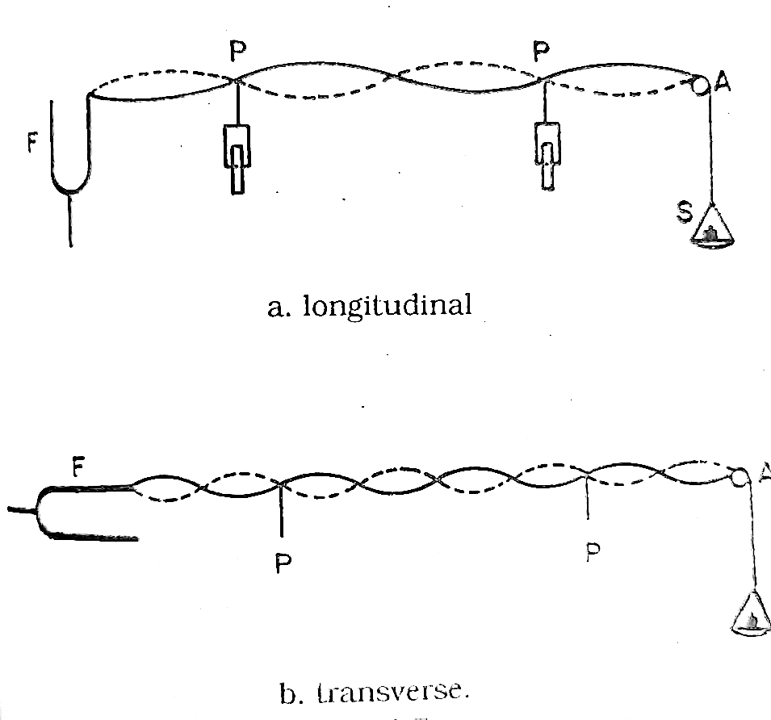

**Figure 2:** Longitudinal and transverse mode of vibration

Now, if the tuning fork is vibrated, then two types of the wave will be generated on the string depending on the direction of vibration. If the direction of vibration of the tuning fork is parallel to the length of the string. Then longitudinal wave is generated in the string and frequency of the tuning fork N becomes double the frequency n of the when the direction of vibration of the tuning fork is perpendicular to the length of the string the transverse wave is produced in the string and frequency of the tuning fork N, is equal to the frequency ‘n’ of the string.

In the transverse case, the frequency $f$ of the fork is same as $f^{'}$, the frequency of the string. why didn't the longitudinal case the frequency of the fork $f$ is double of $f^{'}$. This is because in the longitudinal case, the vibration is produced by the alternating pulls upon the end of the string by the prong of the fork. Each movement of the prong to the right pulls the string tight, the string is stretched, and this occurs in the middle of the swing, twice in every vibration. Thus, in this case the frequency of the string is half that of the fork, or in other words, the frequency of the fork is twice the frequency of the string.

Therefore, for transverse position, the frequency of the fork is,

$$f=f^{'}=\frac{1}{2l}\sqrt{\frac{τ}{μ}}…………………(1)$$

Where $l$ is the length of a segment or loop between two consecutive nodes of the string. Thus,

$$f^{2}=\frac{1}{{4l}^{2}}\frac{τ}{μ}$$

$$∴\frac{τ}{l^{2}}=4μf^{2}=constant$$

For longitudinal position,

$$f=2f^{'}=\frac{2}{2l}\sqrt{\frac{τ}{μ}}=\frac{1}{l}\sqrt{\frac{τ}{μ}}………\left(2\right)$$

$$\frac{τ}{l^{2}}=μf^{2}=constant$$

Test by altering the tension $τ$ and hence the wavelength, the frequency of the turning fork can be determined and also $\frac{τ}{l^{2}}=$ constant can be found which verifies the laws of transverse vibration in a string.

1. **Apparatus**

*The components required to conduct this experiment include: -*

* + *Melde’s apparatus (electrically maintained tuning fork)*
  + *String*
  + *Electronic balance*
  + *Metre Ruler*
  + *Pan (to hold the weights)*

1. **Analysis and Calculation**

Mass of the scale pan, w = 23.8 gm

Length of the string L = 104.8 c

Mass of the string, M = 0.4 gm

So, the mass per unit length of the thread, 𝜇 = $\frac{M}{L}$ = $\frac{0.4}{104.8}=0.00382 gm/cm$

**Table 1: Table for Transverse position**

|  |  |  |  |  |  |  |  |  |  |
| --- | --- | --- | --- | --- | --- | --- | --- | --- | --- |
| **No of Observation** | **Total no of loops between the fixed ends** | **Load on the scale pan** 𝒘𝒕  **(gm)** | **Tensio**n 𝑟=(𝒘+𝒘𝒕) 𝒈  **(dynes)** | **Distance between the pins G**  **(cm)** | **No of loops between the pins N** |  | **Frequency of the fork f**  **f’= $\frac{1}{2l}\sqrt{\frac{τ}{μ}}$**  **(Vibration/sec)** | **Mean frequency *f2***  **(Vibration/sec)** | $\frac{τ}{l^{2}}$**= constant** |
| **1** | 4 | 5 | 28224 | 112.5 | 4 | 28.13 | 48.13 | 48.64 | 35.67 |
| **2** | 3 | 10 | 33124 | 90 | 3 | 30 | 49.08 | 36.80 |
| **3** | 2 | 15 | 38024 | 65 | 2 | 32.5 | 48.54 | 36 |

**Now,** frequency of the fork **f = 48.64 vibration/sec**

1. **Result**

The law of transverse vibration of string is verified by showing $\frac{τ}{l^{2}}$**=** constant and the frequency of the tuning fork is 48.64 Vibration/sec.

1. **Discussion**

This experiment was conducted to verify the laws of transverse vibration of strings and to determine the frequency of a tuning fork by Melde’s experiment. The main objective of this experiment is to find out the frequency of an electrically maintained tuning fork by transverse mode of vibration. A wave is a disturbance that travels through space and time, transferring energy without the transfer of matter. A wave can be described as a pattern of oscillations or vibrations that propagate through a medium, such as water, air, or even empty space.Waves can be characterized by a variety of properties, such as their frequency, wavelength, amplitude, and speed. The frequency of a wave refers to the number of oscillations per unit of time, while the wavelength is the distance between two successive peaks or troughs of the wave. The amplitude, on the other hand, is the maximum displacement of the wave from its equilibrium position, and the speed is the rate at which the wave propagates through the medium. While performing this experiment, we were being introduced to some unknown properties like node, antinode etc. A node is a point on a standing wave where the amplitude of the wave is zero. In other words, at a node, the wave is at rest. Nodes occur at fixed intervals along the medium in which the wave is propagating. For example, in a vibrating guitar string, nodes occur at the fixed ends of the string.An antinode is a point on a standing wave where the amplitude of the wave is maximum. In other words, at an antinode, the wave oscillates with maximum displacement. Antinodes occur at the midpoint between two adjacent nodes. For example, in a vibrating guitar string, the midpoint of the string vibrates with maximum displacement, creating an antinode. Frequency is the fundamental property of a wave. It describes how often the wave oscillates per unit of time. It is defined as the number of cycles per second and is measured in units of Hertz (Hz). In summary, frequency is a crucial parameter in understanding and characterizing waves, and it has important implications for a wide range of physical phenomena. While conducting this experiment, adjustment (of the fork) is done as fork-end and weight must produce nodes. Amplitude is max when fork frequency is equal to the string frequency when vibrating. Loop measurements must be taken when the loops are stable. Length measurements must be taken with ruler parallel to the measuring component to avoid incorrect readings. Systematic error (zero error) of the electronic balance along with human parallax error may account for inaccurate measurements. Essentially a low-risk experiment however adequate safety procedures should always be appropriated. Since an electronic equipment is being utilized, this experiment prompts a fire hazard so fire-extinguishers should be kept nearby. After completing the experiment, we now know about the tuning fork, wave, node, antinode, frequency etc.

1. **References**

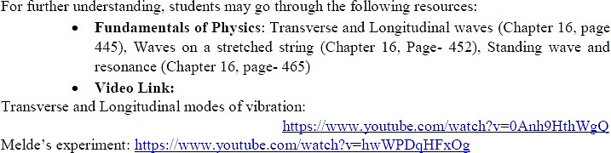Resources for the experiment: